ISM6137

Statistical Data Mining

MS BAIS, Spring 2023

**Swathi Banna | Matthew Southworth**

**Rahul Vemula | Jaswanth Bugguna**

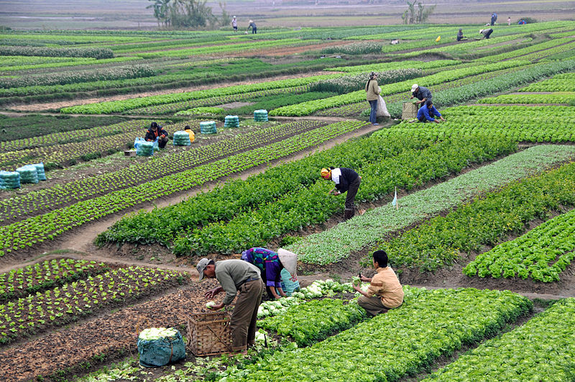

**Factors Affecting AgricultureProduction Value In Various Countries**

**Table of Contents**

**Table of Contents 2**

**Executive Summary 3**

**Problem Definition & Significance 3**

**Prior Literature 4**

**Data Source/Preparation 5**

**Source 5**

**Available variables - Data Dictionary 5**

**Data Joins and Cleansing 6**

**Variable Selection 6**

**Variable Choice 7**

**Exploratory Data Analysis & Visualizations 8**

**Models 10**

**Quality Checks 11**

**Insights & Recommendations 11**

**References 11**

**Appendix 12**

1. **Executive Summary**
2. **Problem Definition & Significance**
3. **Prior Literature**

|  |  |  |  |
| --- | --- | --- | --- |
| **Source** | **Research Question** | **Predictors** | **Findings** |
| The Effect of Government Expenditures, Domestic Investment and Foreign Investment to the Economic Growth of Primary Sector in Central Kalimantan -  Suryani Magdalena, Rony Suhatman | How does the economic growth of primary sector (agriculture, farm field, forestry, fisheries, mining and quarrying) be affected by Government Expenditures, Domestic Investment and Foreign Investment | Government Expenditures  Domestic Investment (DI)  Foreign Investment (FI)  Data Source:  BPS of Central Kalimantan Province, 2020 | * Used OLS with log transform on X variables. * Govt spending has a positive impact on economic growth whereas DI and FI have no impact. * Investments are mainly diverted to industries like manufacturing and construction. * If investors are encouraged by providing a conducive climate, it can help in improving the economic growth in the primary sector. |
| The Impact of Government Expenditure in Agriculture and Other Selected Variables on the Value of Agricultural Production in South Africa (1983–2019): Vector Autoregressive Approach  - Etian Ngobeni and Chiedza L. Muchopa | What is the effect of the predictors on the value of production, with a special focus on govt expenditure in agriculture from 1983-2019 | Govt expenditure  Annual average rainfall  Consumer price index (CPI)  Food import value (FIV)  Population  Data Source:  Food and Agricultural Organisation (FAO)- Population  South African Reserve Bank (SARB)-Yearly Govt expenditure  The World Bank - Annual average rainfall, CPI  Quantec databases-Value of agricultural production, FIV | * Johansen cointegration test is used to find   the long-run relationship among the variables.   * Granger causality test is used to test for   causality among the variables.   * Govt expenditure and rainfall have a positive   impact on the value of agricultural production.   * Increase in population increases the labor   force and thereby has an indirect impact in increasing the production.   * FIV has positive impact in the short run and   detrimental in the long run.   * CPI has negative impact. |
| CONTRIBUTION OF FOOD PRODUCTION SECTOR  TO THE INCREASE OF EMPLOYMENT – COMPARATIVE  ANALYSIS OF SLOVENIA, CROATIA, AND SERBIA2 | How does an increase in operating income increase employment in food production and related sectors and how is it related to national employment? | Companies  Operating revenue  Source:  Official financial statements for 2012  Original data from authors | * Large percentage of enterprises are small to med sized. Contributes to rural economic development in these countries.   Shown to have a Linear link in Slovenia and Croatia but no relationship in Serbia. |
| Public sector expenditure in agriculture and economic growth in Nigeria: An empirical investigation | What is the effect of expenditures on agriculture to the economy and how do changes affect the economy in the short and long run. | Government expenditures  Capital spending  Recurrent spending  Government support programs  Total revenue  Data Source: Sources:  CBN Statistical bulletin (2001) and (2005)  National Bureau of Statistics (NBS) (2007)  The Nigerian Statistical Fact Sheets on Economic and Social Development | * Capital spending was found to have a direct and sustained influence on agriculture and total GDP and growth rate.. * Data separated into recurrent and sustained spending required altering model to account for variable changes.. * There was a direct and significant relationship on long term growth * This also promoted overall growth in the economy through development of rural areas with agricultural workers and support of government programs. |
| FACTORS AFFECTING AGRICULTURAL PRODUCTION OF PUNJAB (PAKISTAN) - Hammad Badar, Abdul Ghafoor and Sultan Ali Adil | Punjab province contribute 60% of national agricultural  production. What are the factors affecting the agricultural production ? What is their impact on productivity and efficiency of the agricultural sector? | cropped area   agricultural labour   distribution of improved seed   budgetary expenditure on agricultural research   land reclamation   wheat price support   fertilizer consumption   expenditure on food trading services  Model :- Multiple linear regression is used with a log transform on DV and all IV because of the nonlinear relationship  Data Sources:- Data is sources from official publications of various offices of Govt. of Pakistan and Govt. of Punjab such as Federal Bureau of Statistics, Islamabad, Ministry of Finance, Islamabad, Ministry of Food, Agriculture and Livestock, Islamabad, Planning and Development Department and Bureau of Statistics. | * Cobb-Douglas production mathematical formula is used to describe the relationship between inputs and outputs in the production of goods or services. Expenditure on food trading services( procurement, subsidies, promotion of export and import, management, and distribution of output) affects production. * Some governments provide support prices for certain crops based on region. This affects production positively because farmers tend to produce more because of the guaranteed returns. Also, on the other hand, if there is surplus produce, the government budget gets burdened, so it should encourage the export of goods. * For export, the quality of the output should be high, which again depends on the quality of the seed available and research on production practices. All the factors have an interconnected effect on one another. |
| Determinants and performance index of foreign direct investment in China’s agriculture - Licai Lv, Simei Wen and Qiquan Xiong | To examine the determinants of FDI and evaluate the inward FDI performance in China’s agriculture. Only 1% of total FDI inflows into china is on agriculture. Finding the determinants and real situation of FDI in agriculture is very important | Agriculture Market Size  Agriculture import  Agricultural Export  Agricultural fiscal expenditure  Industrial Policy  **Model –** Multi Variable Regression with log transformation  **DataSources:-**  China Statistical Yearbook and China,  Foreign Economic Statistical Yearbook,  China Foreign Economic and Trade Yearbook,  the United Nations Commodity Trade Database (COMTRADE),  Ministry of Commerce of China database | * The UNCTAD inward FDI performance index measures a country's share of global FDI flows relative to its share of global GDP. * In China, agricultural market size has a significant positive effect on FDI in agriculture. * The model used to study this may have issues with multiple related variables and can be improved with stepwise regression analysis. * Agricultural GDP is the most important factor in determining FDI in Chinese agriculture. * Agricultural market size is positively and significantly correlated with FDI in Chinese agriculture, indicating its importance in attracting FDI. * Empirical results suggest that agricultural market size has a positive impact on FDI in Chinese agriculture, while agricultural import has a negative impact. |
| Obilor, S. I. (2013). The impact of commercial banks’ credit to agriculture on agricultural development in Nigeria: An econometric analysis. *International Journal of Business, Humanities and Technology*, *3*(1), 85-94. | the impact of Agricultural Credit Guarantee Scheme Fund, agricultural product prices, government fund allocation and commercial banks’ credit to agricultural sector on agricultural productivity. | Commercial Bank’s Credit to the Agricultural Sector  Agricultural Credit Guarantee Scheme loan by purpose  Government Financial Allocation to Agricultural sector  Agricultural Produce Price.  **Datasources:**  the CBN Statistical Bulletin,  data on the banks credit to agricultural sector, interest rates, published data on seminars, journals, magazines, newspapers | Important to check for stationary of series before regression.  Unit test method and dickey-fuller test is used for analysing stationary of series.  Commercial bank credits and price of agricultural products have not made any significant impact on agricultural productivity,  Agricultural Credit Guarantee Scheme Loan and government financial allocation had made positive impact. |
| Abdul Rehman, Abbas Ali Chandio, Imran Hussain, Luan Jingdong,  Fertilizer consumption, water availability and credit distribution: Major factors affecting agricultural productivity in Pakistan,  Journal of the Saudi Society of Agricultural Sciences,  Volume 18, Issue 3,  2019. | To examine the various factors effecting agriculture production in Pakistan over the period 1978-2015. | cropped area  water availability  fertilizer consumption  Improved seeds distribution  credit distribution  Data Source:  Pakistan Bureau of Statistics, the Statistical Year Books and the Economic Survey of Pakistan | * fertilizer consumption has signification impact on agriculture production. * improved seed distribution and credit distribution are positive and significantly influence crop production * water availability had a negative impact, but no significant relationship with Agricultural Gross Domestic Product(AGDP) * share of the agricultural sector decreased due to technical developments. |

1. **Data Source/Preparation**
   1. **Source**

The data used in this analysis was obtained for the years 2011 to 2020 from three websites, as follows:

**FAOSTAT**: <https://www.fao.org/faostat/en/#data>

(The Food and Agriculture Organization Corporate Statistical Database)

Features:

Fertilizer Export/Import

Pesticides Production

Drained Organic Soil Bank Credit

Government expenditure Foreign Direct Investment

**WORLD BANK:** <https://data.worldbank.org/indicator/AG.LND.PRCP.MM>

Feature:

Rainfall Index

**AQUASTAT:** <https://www.fao.org/aquastat/en/>

(FAO's Global Information System on Water and Agriculture)

Features:

Power Irrigation

Irrigated Land

**4.2 Available variables - Data Dictionary**

|  |  |  |
| --- | --- | --- |
| Variable | Definition | Type |
| Value of production |  |  |
| Area | Name of the country | Chr |
| Year | The year for which the data is related to | Date |
| Rainfall Index |  |  |
| Fertilizer.nitrogen |  |  |
| Fertilizer.potash |  |  |
| Fertilizer.phosphate |  |  |
| Pesticide |  |  |
| Drained organic soil |  |  |
| Bank credit |  |  |
| Capital central |  |  |
| Capital general |  |  |
| Recurrent central |  |  |
| Recurrent general |  |  |
| Power irrigation |  |  |
| Irrigated land |  |  |
| FDI inflows |  |  |
| FDI outflows |  |  |
| Import |  |  |
| Export |  |  |

* 1. **Data Joins and Cleansing**

**Joins:** All the tables are joined using a combination of two foreign keys: Area and Year

|  |  |  |
| --- | --- | --- |
| Report | Description | Variables |
| Value of agricultural production | The gross production value of agriculture (in 1000 USD) | Value of production |
| Fertilizers by nutrient | Amount of fertilizers used in agriculture | Fertilizer.nitrogen  Fertilizer.potash  Fertilizer.phosphate |
| Pesticides indicators | Pesticides used per value of agricultural production | Pesticide |
| Government expenditure | Amount spent by government on agriculture | Capital central  Capital general  Recurrent central  Recurrent general |
| Credit to agriculture | Amount of loans provided by private/commercial banks to agriculture producers | Bank credit |
| Foreign Direct Investment | FDI in agriculture | FDI inflows  FDI outflows |
| Trade - Crops and live stock products | Import and export value of agricultural products | Import  Export |
|  |  | Rainfall Index |
|  |  | Drained organic soil |
|  |  | Power irrigation |
|  |  | Irrigated land |

**Cleansing:**